**Setting up an AWS Hadoop Cluster**

The following process shows how you can setup cluster on Amazon Cloud using Amazon Web Services (AWS) and deploy Hadoop. By no means are these production level setups, but it help you to quickly start interacting with Hadoop’s distributed file system and even run Map-Reduce jobs.

Process Steps

1. Spin Up AWS Micro-Instances
2. SSH Configuration
3. Install Hadoop
4. Start Hadoop Cluster
5. Working with HDFS

Before we begin, it’s important to roughly understand the three components of Apache Hadoop project:

1. **Hadoop Distributed File System (HDFS)** is a distributed file system based off Google File System (GFS) that splits files into “blocks” and stores them redundantly on several relatively cheap machines, known as DataNodes. Access to these DataNodes is coordinated by a relatively high-quality machine, known as a NameNode.
2. **Hadoop MapReduce (based off Google MapReduce)** is a paradigm for distributed computing that splits computations across several machines. In the Map task, each machine in the cluster calculates a user-defined function on a subset of the input data. The outputted data of the Map task is shuffled around the cluster of machines to be grouped or aggregated in the Reduce task.
3. **YARN (unofficially Yet Another Resource Negotiator)** is a new feature in Hadoop 2.0 (released in 2013) that manages resources and job scheduling, much like an operating system. This is an important improvement, especially in productions with multiple applications and users, but we won’t focus on this for now.

**Spin up AWS EC2 Instances**

AWS provides on-demand computing resources and services in the cloud, with pay-as-you-go pricing. For example, you can run a server on AWS that you can log on to, configure, secure, and run just as you would a server that’s sitting in front of you. As well as selling premium instances, AWS also offers free micro-instances for one year which you can use for this tutorial.

Log into your AWS account under [aws.amazon.com](http://aws.amazon.com/). If you currently don’t have one, go ahead and sign up for one.

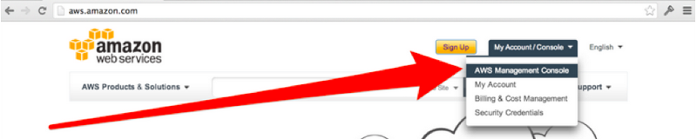

**Launching Multiple AWS Micro-Instances**

You can do a lot of different things with AWS. For now, let’s just start a virtual machine. Click on EC2 (“Elastic Cloud Compute”).

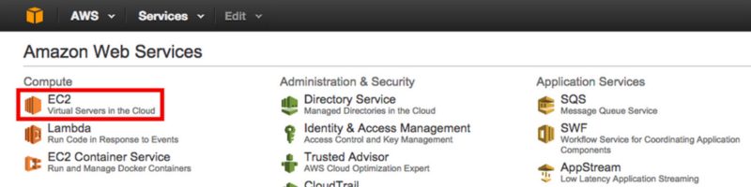

Click on “Launch Instance”. It’s worth noting that AWS has different regions, and that you can launch an instance in any of them. (So if you’ve always wanted a server in Brazil or Japan, this is your chance!) Your choice will affect both latency and price — by default, it’s best to go with the region that’s closest to you.

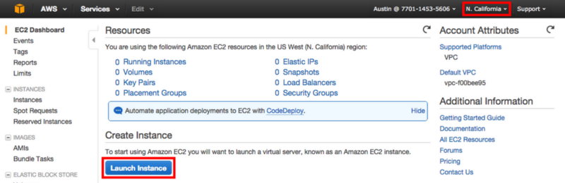

Now it’s time to select the image for your VM. For this tutorial, we’ll use Ubuntu Server 14.04 LTS (HVM). Be sure to select the 64-bit.

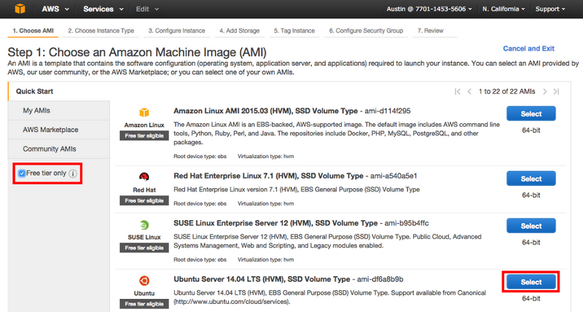

Now choose your instance size. ‘**t2.micro’** instances should be sufficient to start playing with HDFS and MapReduce. Be sure to terminate the instances if you want AWS to keep more free credits for the month. For practice you can try spinning up 4 nodes, treating one as the NameNode(master) and the remaining three as DataNodes.

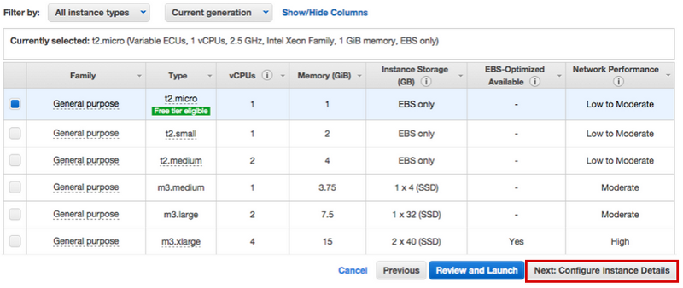

We can then specify the number of instances to spin up. In this tutorial we will spin up 4 instances where 1 node will act as the NameNode and the remaining 3 will be DataNodes.

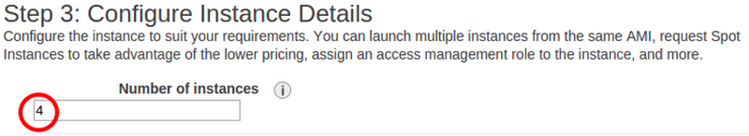

We will use the default storage size for each instance. In the future, if you plan on storing larger amounts of data, here is the place to change it before launching the instances.

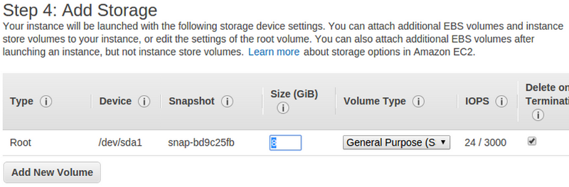

Next we can give these instances a name so they are easily recognizable among other potential instances in your account. Here we gave all the instances the name ‘master’. This can be modified as well after you have launched your instances.

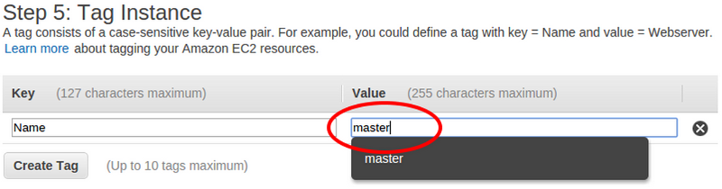

The next step will be to configure the security groups setting for these instances. For this exercise, all the ports are open for ease of access. It should be noted that these settings should be much more strict if put in production. If a security group does not exist with the following configuration, you can create a new security group with the following settings.

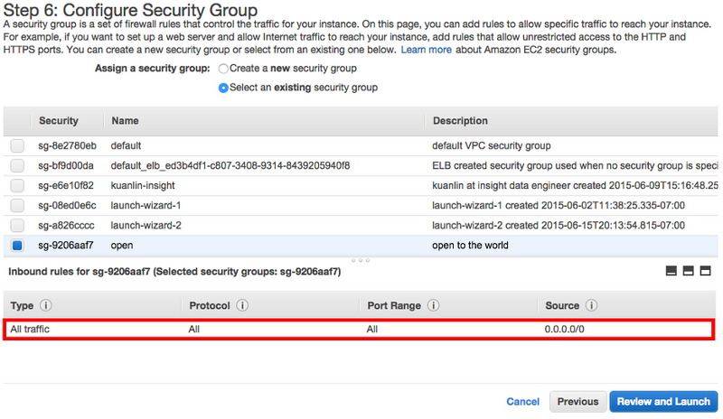

We will then review our instances and launch.

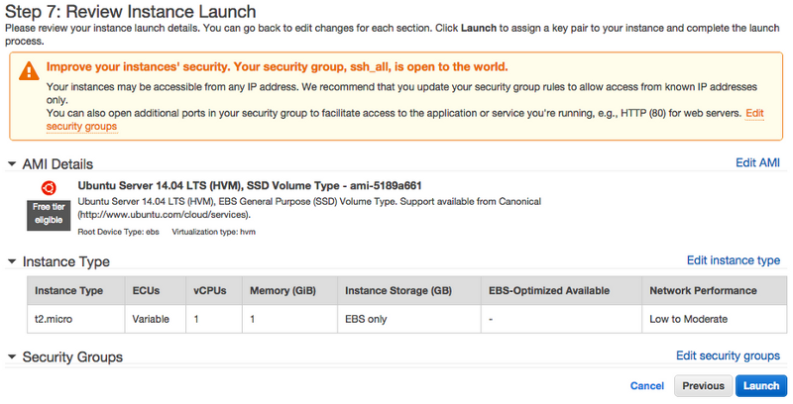

You will then be asked to choose a pem-key which will be used to login to these instances. If this is your first time, you can generate a new pem-key and download it to you computer. For this tutorial we will assume you have saved the pem key to the ~/.ssh folder.

**WARNING: If you lose your pem-key there is no way to recover it and thus lose access to any instances that are associated with this pem-key**.

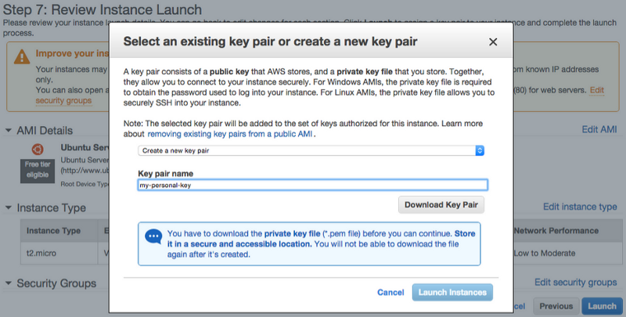

Congratulations! AWS instances are now spinning up! Let’s log into them.

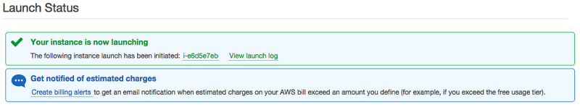

**Logging into an EC2 Instance**

Return to the AWS console. You should now see “4 Running Instances” if you chose 4 instances in the beginning. Click on it.

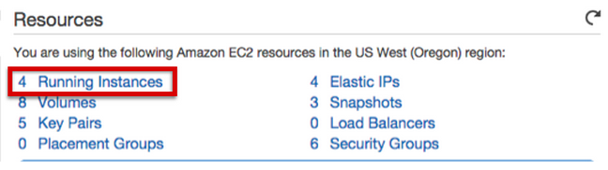

You can then choose one of these instances. You can rename the instances by clicking the pencil to the right of the instance name, which will be helpful for technologies that use a single “master” that needs to be distinguished from than the rest. You should now be able to see the public IP address of your Virtual Machine (VM). This is the endpoint we’re going to use to SSH into the machine.

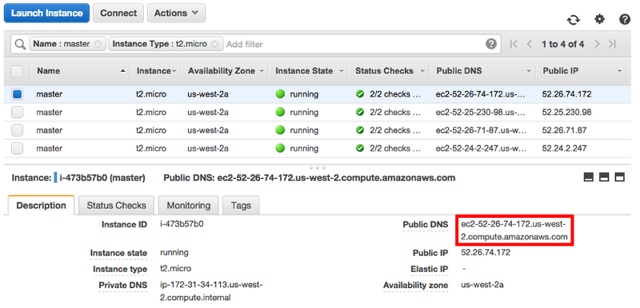

For the remainder of this process, we will be referencing the Public DNS quite a bit when installing Hadoop. In any code snippets where there is **bolded text**, you will need to swap it out with appropriate values.

For example, **namenode_public_dns** should be replaced with something like **ec2–52–26–74–172.us-west-2.compute.amazonaws.com**

e.g:  
your Namenode public DNS is ec2–52–26–74–172.us-west-2.compute.amazonaws.com

**local**$ ssh -i ~/.ssh/my-pem-key.pem ubuntu@**namenode_public_dns**

should translate to

**local**$ ssh -i ~/.ssh/my-pem-key.pem ubuntu@**ec2–52–26–74–172.us-west-2.compute.amazonaws.com**

Fellows in the past have found it useful to simply copy all the **Public DNS(s)** into a text file for easy reference later on. At this point you should decide which Public DNS will be the NameNode and the remaining Public DNSs be the DataNodes.

Example text file:

namenode_public_dns => ec2–52–26–74–172.us-west-2.compute.amazonaws.com  
datanode1_public_dns => ec2–52–26–34–168.us-west-2.compute.amazonaws.com  
datanode2_public_dns => ec2–52–26–27–192.us-west-2.compute.amazonaws.com  
datanode3_public_dns => ec2–52–26–36–112.us-west-2.compute.amazonaws.com

You need to change the permissions of the pem key that you downloaded from AWS earlier. Do this with the command otherwise SSH’ing will complain that the key is too open (bolded code would be different for your setup):

**local**$ sudo chmod 600 ~/.ssh/**pem_key_filename**

Now let’s SSH into the machine with the following SSH command template:

**local**$ ssh -i ~/.ssh/**pem_key_filename** ubuntu@**namenode_public_dns**

If prompted “Are you sure that you want to continue?”, enter “yes”. After verifying that you can SSH into a node, you can exit with the command exit or Ctrl-D.

**SSH Configuration**

We can make our lives easier by setting up a config file in the ~/.ssh directory such that we do not have to specify the pem key and host address every time we SSH into a node from our local machine. Simply place the following into the ~/.ssh/config file. Create one, if it does not exist.

~/.ssh/config:

Host namenode  
 HostName **namenode_public_dns**  
 User ubuntu  
 IdentityFile ~/.ssh/**pem_key_filename**

Host datanode1  
 HostName **datanode1_public_dns**  
 User ubuntu  
 IdentityFile ~/.ssh/**pem_key_filename**

Host datanode2  
 HostName **datanode2_public_dns**  
 User ubuntu  
 IdentityFile ~/.ssh/**pem_key_filename**

Host datanode3  
 HostName **datanode3_public_dns**  
 User ubuntu  
 IdentityFile ~/.ssh/**pem_key_filename**

**Passwordless SSH**

The NameNode in the Hadoop cluster needs to be able to communicate with the other DataNodes in the cluster. This is done by configuring passwordless SSH between the NameNode and the DataNodes.

We will first need to transfer your pem key from your local computer to the NameNode. This allows us to initially SSH into DataNodes from the NameNode. We will also copy over the config file in our ~/.ssh folder.

**local**$ scp ~/.ssh/**pem_key_filename** ~/.ssh/config namenode:~/.ssh

Next we will SSH into the NameNode and create an authorization key. This fingerprint will then be added to the authorized_keys file on the NameNode and all the DataNodes. The first time you SSH into the node it will probably ask you if you are sure you want to connect. Answer yes.

For example you may see something like this:

**local**$ ssh namenode

The authenticity of host ‘ec2–52–26–234–93.us-west-2.compute.amazonaws.com (172.31.35.245)’ can’t be established. ECDSA key fingerprint is df:2f:34:e7:2d:51:7b:b2:38:86:b8:f0:c6:c2:8d:0b.  
Are you sure you want to continue connecting (yes/no)? **yes**

On the NameNode we can create the public fingerprint, found in ~/.ssh/id_rsa.pub, and add it first to the NameNode’s authorized_keys

**namenode**$ ssh-keygen -f ~/.ssh/id_rsa -t rsa -P ""  
**namenode**$ cat ~/.ssh/id_rsa.pub >> ~/.ssh/authorized_keys

Now we need to copy the public fingerprint to each DataNode’s~/.ssh/authorized_keys. This should enable the password-less SSH capabilities from the NameNode to any DataNode.

**namenode**$ cat ~/.ssh/id_rsa.pub | ssh datanode1 'cat >> ~/.ssh/authorized_keys'  
**namenode**$ cat ~/.ssh/id_rsa.pub | ssh datanode2 'cat >> ~/.ssh/authorized_keys'  
**namenode**$ cat ~/.ssh/id_rsa.pub | ssh datanode3 'cat >> ~/.ssh/authorized_keys'

We can check this by trying to SSH into any of the DataNodes from the NameNode. You may still be prompted if you are sure you want to connect, but there should be no password requirement.

**namenode**$ ssh ubuntu@**datanode1_public_dns**

**Install Hadoop**

Now that password-less SSH is setup, we can begin installation of Hadoop and modify common configurations across the NameNode and DataNodes. Typically this is easier to do when you have 4 terminals open with each terminal representing a node. Below shows an example. If you’re using iTerm2 or Terminator, toggling the broadcast input to all panes can help reduce mistakes during installation.

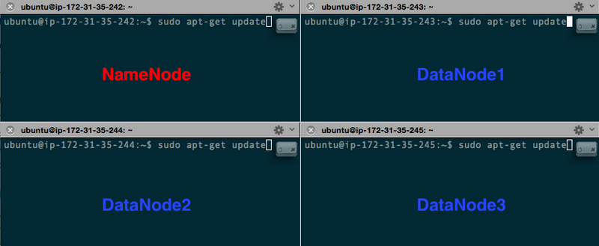

On fresh AWS instances, Java is not installed. We will be installing the openjdk-7-jdk package to be used by Hadoop.

**allnodes**$ sudo apt-get update  
**allnodes**$ sudo apt-get install openjdk-7-jdk

We can test to see if Java installed correctly with the following command

**allnodes**$ java -version

java version "1.7.0_79"  
OpenJDK Runtime Environment (IcedTea 2.5.5) (7u79–2.5.5–0ubuntu0.14.04.2)  
OpenJDK 64-Bit Server VM (build 24.79-b02, mixed mode)

Next we’ll install Hadoop onto all the nodes by first saving the binary tar files to ~/Downloads and extracting it to the /usr/local folder.

**allnodes**$ wget <http://apache.mirrors.tds.net/hadoop/common/hadoop-2.7.1/hadoop-2.7.1.tar.gz> -P ~/Downloads  
**allnodes**$ sudo tar zxvf ~/Downloads/hadoop-* -C /usr/local  
**allnodes**$ sudo mv /usr/local/hadoop-* /usr/local/hadoop

**Environment Variables**

Now we’ll need to add some Hadoop and Java environment variables to ~/.profile and source them to the current shell session.

**~/.profile:**

export JAVA_HOME=/usr  
export PATH=$PATH:$JAVA_HOME/bin

export HADOOP_HOME=/usr/local/hadoop  
export PATH=$PATH:$HADOOP_HOME/bin

export HADOOP_CONF_DIR=/usr/local/hadoop/etc/hadoop

Then load these environment variables by sourcing the profile

**allnodes**$ . ~/.profile

**Hadoop Configurations**

For a basic setup of Hadoop, we’ll be changing a few of the configurations in the Hadoop directory defined now by HADOOP_CONF_DIR environment variable. All the current configuration changes will be applied to the NameNode and all the DataNodes. After these changes, we will apply configurations specific to the NameNode and DataNodes.

Here are the following files to focus on:

* $HADOOP_CONF_DIR/hadoop-env.sh
* $HADOOP_CONF_DIR/core-site.xml
* $HADOOP_CONF_DIR/yarn-site.xml
* $HADOOP_CONF_DIR/mapred-site.xml (This file currently does not exist in the default Hadoop installation, but a template is available. We’ll make a copy of the template and rename it to mapred-site.xml)

**Common Hadoop Configurations on all Nodes**

Let’s start with $HADOOP_CONF_DIR/hadoop-env.sh. Currently only root users can edit files in the Hadoop directory, but we’ll change this after all configurations have been applied. To edit the configurations files, you can simply add a sudo before the text editor of your choice, for example

**allnodes**$ sudo vim $HADOOP_CONF_DIR/hadoop-env.sh

The only thing that needs changing is the location of JAVA_HOME in the file. Simply replace${JAVA_HOME} with /usr which is where Java was just previously installed.

**$HADOOP_CONF_DIR/hadoop-env.sh:**

# The java implementation to use.  
export JAVA_HOME=/usr

The next file to modify is the $HADOOP_CONF_DIR/core-site.xml. Here we will declare the default Hadoop file system. The default configuration is set to the localhost, but here we will want to specify the NameNode’s public DNS on port 9000. Scroll down in the xml file to find the configurations tag and be sure to change the file to look like the following

**$HADOOP_CONF_DIR/core-site.xml:**

<configuration>  
 <property>  
 <name>fs.defaultFS</name>  
 <value>hdfs://**namenode_public_dns**:9000</value>  
 </property>  
</configuration>

The next file to modify is the $HADOOP_CONF_DIR/yarn-site.xml. Scroll down in the xml file to find the configurations tag and be sure to change the file to look like the following

**$HADOOP_CONF_DIR/yarn-site.xml:**

<configuration>

<! — Site specific YARN configuration properties →

<property>  
 <name>yarn.nodemanager.aux-services</name>  
 <value>mapreduce_shuffle</value>  
 </property>   
 <property>  
 <name>yarn.nodemanager.aux-services.mapreduce.shuffle.class</name>  
 <value>org.apache.hadoop.mapred.ShuffleHandler</value>  
 </property>  
 <property>  
 <name>yarn.resourcemanager.hostname</name>  
 <value>**namenode_public_dns**</value>  
 </property>  
</configuration>

The last configuration file to change is the $HADOOP_CONF_DIR/mapred-site.xml. We will first need to make a copy of the template and rename it.

**allnodes**$ sudo cp $HADOOP_CONF_DIR/mapred-site.xml.template $HADOOP_CONF_DIR/mapred-site.xml

Scroll down in the xml file to find the configurations tag and be sure to change the file to look like the following

**$HADOOP_CONF_DIR/mapred-site.xml:**

<configuration>  
 <property>  
 <name>mapreduce.jobtracker.address</name>  
 <value>**namenode_public_dns**:54311</value>  
 </property>  
 <property>  
 <name>mapreduce.framework.name</name>  
 <value>yarn</value>  
 </property>  
</configuration>

**NameNode Specific Configurations**

Now that all the common configurations are complete, we’ll finish up the NameNode specific configurations. On the NameNode, all that remains are the following:

* adding hosts to /etc/hosts
* modifying the configurations in $HADOOP_CONF_DIR/hdfs-site.xml
* defining the Hadoop master in $HADOOP_CONF_DIR/masters
* defining the Hadoop slaves in $HADOOP_CONF_DIR/slaves

Let’s start with adding to the hosts file located under /etc/hosts. We will need to add each node’s public DNS and hostname to the list. The hostname can be found with the following

**allnodes**$ echo $(hostname)

or by taking the first part of the private DNS (e.g. ***ip-172–31–35–242***.us-west-2.compute.internal)

By default, 127.0.0.1 localhost is present, so we can add under it to look like the following (ignoring the IPv6 settings):

**/etc/hosts:**

127.0.0.1 localhost  
**namenode_public_dns namenode_hostname**  
**datanode1_public_dns datanode1_hostname**  
**datanode2_public_dns datanode2_hostname**  
**datanode3_public_dns datanode3_hostname**

# The following lines are desirable for IPv6 capable hosts  
::1 ip6-localhost ip6-loopback  
fe00::0 ip6-localnet  
ff00::0 ip6-mcastprefix  
ff02::1 ip6-allnodes  
ff02::2 ip6-allrouters  
ff02::3 ip6-allhosts

We can now modify the $HADOOP_CONF_DIR/hdfs-site.xml file to specify the replication factor along with where the NameNode data will reside. For this setup, we will specify a replication factor of 3 for each data block in HDFS.

Scroll down in the xml file to find the configurations tag and be sure to change the file to look like the following

**$HADOOP_CONF_DIR/hdfs-site.xml:**

<configuration>  
 <property>  
 <name>dfs.replication</name>  
 <value>3</value>  
 </property>  
 <property>  
 <name>dfs.namenode.name.dir</name>  
 <value>file:///usr/local/hadoop/hadoop_data/hdfs/namenode</value>  
 </property>  
</configuration>

The current path where data on the NameNode will reside does not exist, so we’ll need to make this before starting HDFS.

**namenode**$ sudo mkdir -p $HADOOP_HOME/hadoop_data/hdfs/namenode

Next we’ll need to add a masters file to the $HADOOP_CONF_DIR directory

**namenode**$ sudo touch $HADOOP_CONF_DIR/masters

then insert the NameNode’s hostname in that file

**$HADOOP_CONF_DIR/masters:**

**namenode_hostname**

We will also need to modify the slaves file in the $HADOOP_CONF_DIR directory to the following. By default localhost is present, but we can remove this.

**$HADOOP_CONF_DIR/slaves**

**datanode1_hostname**  
**datanode2_hostname**  
**datanode3_hostname**

Now that all configurations are set on the NameNode, we will change the ownership of the$HADOOP_HOME directory to the user ubuntu

**namenode$** sudo chown -R ubuntu $HADOOP_HOME

**DataNode Specific Configurations**

Let’s now move onto the final configurations for the DataNodes. We will need to first SSH into each DataNode and only configure the $HADOOP_CONF_DIR/hdfs-site.xml file

Scroll down in the xml file to find the configurations tag and be sure to change the file to look like the following

**$HADOOP_CONF_DIR/hdfs-site.xml:**

<configuration>  
 <property>  
 <name>dfs.replication</name>  
 <value>3</value>  
 </property>  
 <property>  
 <name>dfs.datanode.data.dir</name>  
 <value>file:///usr/local/hadoop/hadoop_data/hdfs/datanode</value>  
 </property>  
</configuration>

Just like on the NameNode, we will need to create the directory specified in the$HADOOP_CONF_DIR/hdfs-site.xml file.

**datanodes**$ sudo mkdir -p $HADOOP_HOME/hadoop_data/hdfs/datanode

Now that all configurations are set on the DataNode, we will change the ownership of the$HADOOP_HOME directory to the ubuntu user

**datanodes**$ sudo chown -R ubuntu $HADOOP_HOME

**Start Hadoop Cluster**

We can now start up HDFS from the Namenode by first formatting it and then starting HDFS. An important thing to notes is that every time the NameNode is formatted, all of the data previously on it is lost.

**namenode**$ hdfs namenode -format  
**namenode**$ $HADOOP_HOME/sbin/start-dfs.sh

When asked “The authenticity of host ‘Some Node’ can’t be established. Are you sure you want to continue connecting (yes/no)?” type yes and press enter.**You may need to do this several times — keep typing yes, then enter, even if there is no new prompt**, since it’s the first time for Hadoop to log into each of the Datanodes.

You can go to **namenode_public_dns**:50070 in your browser to check if all Datanodes are online. If the webUI does not display, check to make sure your EC2 instances have security group settings that include All Traffic and not just SSH. You should see 3 live nodes, otherwise there was an error in the previous steps.

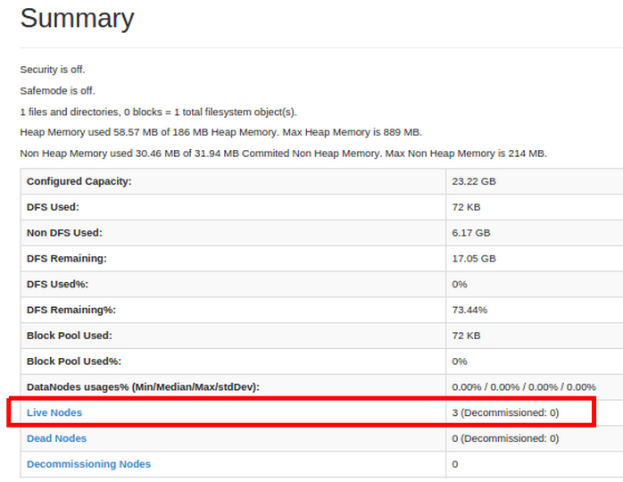

Now let’s start up YARN as well as the MapReduce JobHistory Server.

**namenode**$ $HADOOP_HOME/sbin/start-yarn.sh  
**namenode**$ $HADOOP_HOME/sbin/mr-jobhistory-daemon.sh start historyserver

You can check to make sure all Java processes are running with the jps command on the NameNode and DataNodes (your process ids will be different though).

**namenode**$ jps  
21817 JobHistoryServer  
21853 Jps  
21376 SecondaryNameNode  
21540 ResourceManager  
21157 NameNode

**datanodes**$ jps  
20936 NodeManager  
20792 DataNode  
21036 Jps

**Working with HDFS**

You’re now ready to start working with HDFS by SSH’ing to the NameNode. The most common commands are very similar to normal Linux File System commands, except that they are preceded by hdfs dfs. Below are some common commands and a few examples to get used to HDFS.

**Common HDFS Commands**

List all files and folder in directory

* hdfs dfs -ls <folder name>

Make a directory on HDFS

* hdfs dfs -mkdir <folder name>

Copy a file from the local machine (namenode) into HDFS

* hdfs dfs -copyFromLocal <local folder or file name>

Delete a file on HDFS

* hdfs dfs -rm <file name>

Delete a directory on HDFS

* hdfs dfs -rmdir <folder name>

**HDFS Examples**

# create local dummy file to place on HDFS  
**namenode**$ echo "Hello this will be my first distributed and fault-tolerant data set\!" | cat >> my_file.txt

# list directories from top level of HDFS  
**namenode**$ hdfs dfs -ls /  
# This should display nothing but a temp directory

# create /user directory on HDFS  
**namenode**$ hdfs dfs -mkdir /user  
**namenode**$ hdfs dfs -ls /  
Found 1 items  
drwxr-xr-x — ubuntu supergroup 0 2015–05–06 22:41 /user

# copy local file a few times onto HDFS  
**namenode**$ hdfs dfs -copyFromLocal ~/my_file.txt /user  
**namenode**$ hdfs dfs -copyFromLocal ~/my_file.txt /user/my_file2.txt  
**namenode**$ hdfs dfs -copyFromLocal ~/my_file.txt /user/my_file3.txt

# list files in /user directory  
**namenode**$ hdfs dfs -ls /user  
Found 1 items  
-rw-r — r — 3 ubuntu supergroup 50 2015–05–06 22:43 /user/my_file.txt  
-rw-r — r — 3 ubuntu supergroup 50 2015–05–06 22:43 /user/my_file2.txt  
-rw-r — r — 3 ubuntu supergroup 50 2015–05–06 22:43 /user/my_file3.txt

# clear all data and folders on HDFS  
**namenode**$ hdfs dfs -rm /user/my_file*  
15/05/06 22:49:06 INFO fs.TrashPolicyDefault: Namenode trash configuration: Deletion interval = 0 minutes, Emptier interval = 0 minutes.  
Deleted /user/my_file.txt  
15/05/06 22:49:06 INFO fs.TrashPolicyDefault: Namenode trash configuration: Deletion interval = 0 minutes, Emptier interval = 0 minutes.  
Deleted /user/my_file2.txt  
15/05/06 22:49:06 INFO fs.TrashPolicyDefault: Namenode trash configuration: Deletion interval = 0 minutes, Emptier interval = 0 minutes.  
Deleted /user/my_file3.txt  
**namenode**$ hdfs dfs -rmdir /user

**What Next?**

Now that you have installed Hadoop, you can start running example MapReduce jobs found in the **$HADOOP_HOME/share/hadoop/mapreduce/ folder**. The jar file is named hadoop-mapreduce-examples-*.jar and further documentation on using the jar file can be found here, Hadoop MapReduce Examples.

If writing MapReduce in Java isn’t your cup of tea, you can also look at higher abstractions such as Pig and Hive to run jobs on your dataset in HDFS.

While running any MapReduce job you can monitor each job by going to port 8088 on the NameNode

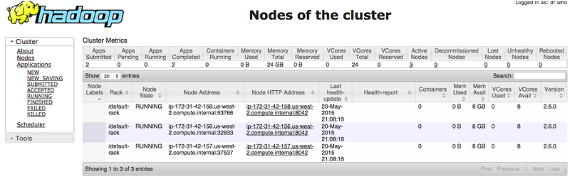

and you can see the history of jobs run on Hadoop at**namenode_public_dns**:19888

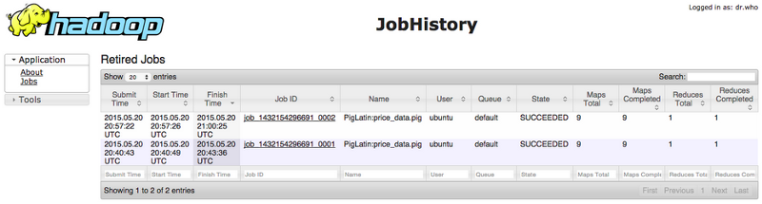

When you are finished with your instances, be sure to shut them down or you may start incurring charges from AWS for the month.

To terminate instances when you are finished with them, you can go to AWS Console and find the Instances tab along the left panel. Next highlight the instances you wish to terminate and the click on **Actions -> Instance State -> Terminate.**

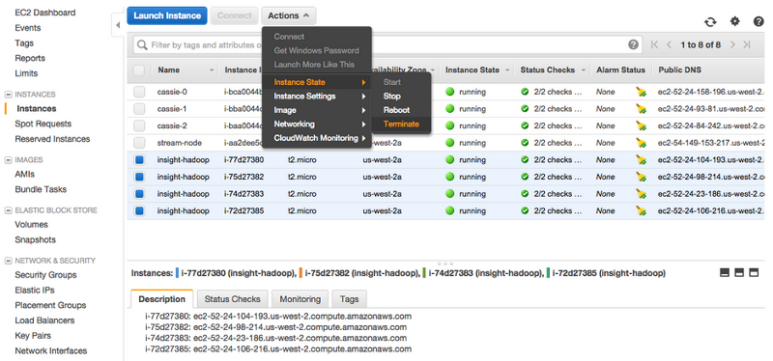

**Final Thoughts**

These types of development setups have helped Insight Fellows hit the ground running and explore various distributed technologies beyond Hadoop such as Kafka, Spark, Storm, Elasticsearch, and Cassandra. Although setting up these systems are not the primary concerns for data engineers, understanding how distributed systems are installed and connected is still a valuable skill.